Packet Tracer - Configuring DHCP Using Cisco IOS

1. Topology

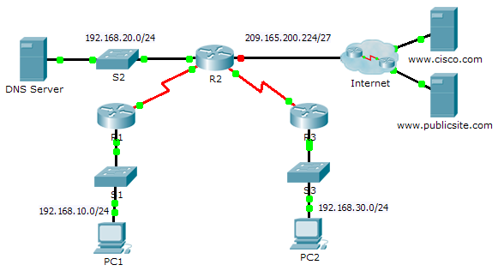

1. Addressing Table

|  |  |  |  |  |
| --- | --- | --- | --- | --- |
| Device | Interface | IPv4 Address | Subnet Mask | Default Gateway |
| R1 | G0/0 | 192.168.10.1 | 255.255.255.0 | N/A |
| S0/0/0 | 10.1.1.1 | 255.255.255.252 | N/A |
| R2 | G0/0 | 192.168.20.1 | 255.255.255.0 | N/A |
| G0/1 | DHCP Assigned | DHCP Assigned | N/A |
| S0/0/0 | 10.1.1.2 | 255.255.255.252 | N/A |
| S0/0/1 | 10.2.2.2 | 255.255.255.252 | N/A |
| R3 | G0/0 | 192.168.30.1 | 255.255.255.0 | N/A |
| S0/0/1 | 10.2.2.1 | 255.255.255.0 | N/A |
| PC1 | NIC | DHCP Assigned | DHCP Assigned | DHCP Assigned |
| PC2 | NIC | DHCP Assigned | DHCP Assigned | DHCP Assigned |
| DNS Server | NIC | 192.168.20.254 | 255.255.255.0 | 192.168.20.1 |

1. Objectives

Part 1: Configure a Router as a DHCP Server

Part 2: Configure DHCP Relay

Part 3: Configure a Router as a DHCP Client

Part 4: Verify DHCP and Connectivity

1. Scenario

A dedicated DHCP server is scalable and relatively easy to manage, but can be costly to have one at every location in a network. However, a Cisco router can be configured to provide DHCP services without the need for a dedicated server. As the network technician for your company, you are tasked with configuring a Cisco router as a DHCP server to provide dynamic allocation of addresses to clients on the network. You are also required to configure the edge router as a DHCP client so that it receives an IP address from the ISP network.

1. Configure a Router as a DHCP Server
   1. Configure the excluded IPv4 addresses.

Configure **R2** to exclude the first 10 addresses from the R1 and R3 LANs. All other addresses should be available in the DHCP address pool.

**ip dhcp excluded-address 192.168.10.1 192.168.10.10**

**ip dhcp excluded-address 192.168.30.1 192.168.30.10**

* 1. Create a DHCP pool on R2 for the R1 LAN.
     1. Create a DHCP pool named **R1-LAN** (case-sensitive).

**ip dhcp pool R1-LAN**

* + 1. Configure the DHCP pool to include the network address, the default gateway, and the IP address of the DNS server.
  1. Create a DHCP pool on R2 for the R3 LAN.
     1. Create a DHCP pool named **R3-LAN** (case-sensitive).

**ip dh pool R3-LAN**

* + 1. Configure the DHCP pool to include the network address, the default gateway, and the IP address of the DNS server.

**network 192.168.30.0 255.255.255.0**

**default-router 192.168.30.1**

**dns-server 192.168.20.254**

1. Configure DHCP Relay
   1. Configure R1 and R3 as a DHCP relay agent.
   2. Set PC1 and PC2 to receive IP addressing information from DHCP.
2. Configure R2 as a DHCP Client
   * 1. Configure the Gigabit Ethernet 0/1 interface on R2 to receive IP addressing from DHCP and activate the interface.

**Interface g0/1**

**ip address dhcp**

**no shutdown**

**Note**: Use Packet Tracer’s **Fast Forward Time** feature to speed up the process or wait until R2 forms an EIGRP adjacency with the ISP router.

* + 1. Use the **show ip interface brief** command to verify that R2 received an IP address from DHCP.

1. Verify DHCP and Connectivity
   1. Verify DHCP bindings.

R2# **show ip dhcp binding**

IP address Client-ID/ Lease expiration Type

Hardware address

192.168.10.11 0002.4AA5.1470 -- Automatic

192.168.30.11 0004.9A97.2535 -- Automatic

* 1. Verify configurations.

Verify that **PC1** and **PC2** can now ping each other and all other devices.